Smart Resume Screening and Job Recommendation System
G. Usha Sai Bhavani  Department of Computer Science and Engineering,  Koneru Lakshmaiah Education Foundation, Bowrampet,  Hyderabad, India.  2420030311@klh.edu.in | P. Sri Durga  Department of Computer Science and Engineering,  Koneru Lakshmaiah Education Foundation, Bowrampet,  Hyderabad, India.  2420030289@klh.edu.in | K. Dharani Harika  Department of Computer Science and Engineering,  Koneru Lakshmaiah Education Foundation, Bowrampet,  Hyderabad, India.  2420030304@klh.edu.in
Dr. Prathusha (Guide)
Department of Computer Science and Engineering,
Koneru Lakshmaiah Education Foundation, Bowrampet,
Hyderabad, India.

Abstract — The Smart Resume Screening and Job Recommendation System is an intelligent data science application that automates resume evaluation and job matching. Traditional recruitment requires recruiters to review large numbers of resumes manually, which is time-consuming, inconsistent and difficult to scale. This work applies Natural Language Processing (NLP) and recommendation techniques to analyze resumes and job descriptions automatically. The system extracts technical skills, educational qualifications, work experience, projects, certifications and job-related keywords from a candidate’s resume, cleans the text through tokenization, stop-word removal, normalization and stemming or lemmatization, and converts the resume and job descriptions into numerical vectors using Term Frequency–Inverse Document Frequency (TF-IDF). Cosine similarity between the vectors measures how closely a candidate matches each job, and the available jobs are ranked by relevance. The system also performs skill-gap analysis by identifying skills required by a job that are missing from the resume, and presents match percentages, recommended jobs, matched skills, missing skills and rankings on an interactive dashboard. The approach reduces manual screening effort and supports personalized, data-driven career recommendations for job seekers and recruiters.
Keywords— Resume Screening, Job Recommendation, Natural Language Processing, TF-IDF, Cosine Similarity, Skill-Gap Analysis, Data Science, Recruitment Automation.
I. INTRODUCTION
Recruitment is a data-intensive process in which recruiters must evaluate large numbers of resumes against the requirements of each open position. Conventional screening is performed manually. While effective for small volumes, it is time-consuming, can be inconsistent between reviewers, and is difficult to scale. Matching a candidate to suitable job descriptions requires significant effort, and candidates in turn find it hard to identify the jobs that best fit their skills and qualifications, or the skills missing from their resumes for a particular role. These challenges motivate an automated, data-driven approach to resume screening and job recommendation.
Advances in Natural Language Processing (NLP) make it possible to analyze unstructured resume text and job descriptions automatically. Text vectorization methods such as TF-IDF, combined with similarity measures such as cosine similarity, allow a resume and a job description to be compared quantitatively and the results to be ranked. This study applies these techniques in a single system that screens resumes, recommends and ranks jobs, and analyzes skill gaps. Its key objectives are: (1) to automate resume screening and reduce manual effort, (2) to analyze resumes and extract relevant candidate information, (3) to match candidates with suitable jobs and rank them by relevance based on their skills and qualifications, and (4) to identify missing skills for specific job roles and present the results on an interactive dashboard so that candidates can understand their skill gaps and areas for improvement.
II. LITERATURE SURVEY
Tejaswini et al. [1] present the design and development of a machine learning based resume ranking system. The work applies data preprocessing and text cleaning, TF-IDF for feature extraction and cosine similarity for matching, with K-Nearest Neighbors (KNN) used to rank resumes. The system automates resume screening, matches resumes with job descriptions using similarity scores and helps recruiters identify relevant candidates from large numbers of resumes. Its focus is on resume ranking; it does not provide job recommendations or skill-gap analysis, and future work could include personalized job recommendations and skill assessment.
Mohanty et al. [2] develop a resume–job match scorer using cosine similarity and NLP. Resumes undergo data cleaning and preprocessing, NLP techniques and TF-IDF vectorization, and cosine similarity is then used to compute a measurable score of how well a resume matches a job description. The approach reduces manual screening effort, but it concentrates on the matching score and does not provide job recommendations. Skill-gap identification and recommendation features are suggested as future work.
Jadhav et al. [3] propose an AI-enabled employment matching platform that combines text preprocessing, TF-IDF feature extraction and cosine similarity for data-based candidate matching. The platform matches candidate profiles with job requirements, provides job recommendations and candidate shortlisting, and uses dashboards for job seekers and recruiters. It may require large and updated job datasets for better accuracy, personalization can be improved, and advanced skill-gap analysis and real-time job updates remain future work.
The surveyed systems show that TF-IDF and cosine similarity are an established basis for resume–job matching. However, each addresses only part of the problem: ranking [1], match scoring [2], or matching with recommendation [3]. None combines resume screening, job matching, recommendation and skill-gap analysis in one system, which is the gap addressed by the proposed work.
III. DATA RESOURCES
The system works with two kinds of textual data: candidate resumes and a collection of job descriptions. Resumes are supplied by the user in PDF or DOC format, and the job descriptions are held in a job descriptions dataset against which each resume is compared. In the first stage of the methodology, resumes and job descriptions are collected and the dataset is prepared.
The raw text of both sources is unstructured and varies widely in format, layout and terminology, so it is preprocessed before analysis. The text is first extracted from the uploaded resume (resume parsing) and cleaned. NLP preprocessing is then applied: tokenization, stop-word removal, normalization, and stemming or lemmatization. From the cleaned resume the system identifies technical skills, educational qualifications, work experience, projects, certifications and job-related keywords; from each job description it identifies the required skills and requirements. Careful preparation of both sources reduces noise and inconsistent wording that would otherwise degrade the similarity scores.
IV. PROPOSED FRAMEWORK: SMART RESUME SCREENING AND JOB RECOMMENDATION SYSTEM
The proposed system accepts a candidate’s resume together with a collection of job descriptions and returns ranked job recommendations and a skill-gap report. It serves job seekers, who gain personalized guidance, and recruiters, who gain a faster and more consistent screening process. It is implemented in Python, using Pandas and NumPy for data processing, NLP libraries such as NLTK or spaCy for text processing, and Streamlit or Flask for the dashboard. The development methodology comprises the following stages (Fig. 1).
A. Resume Upload and Text Extraction
The user uploads a resume in PDF or DOC format. The system parses the file and extracts its text, including skills, qualifications, experience, projects and certifications.
B. NLP Preprocessing
The extracted text and the job descriptions are cleaned and standardized using tokenization, stop-word removal, normalization and stemming or lemmatization, so that the resume and job descriptions are expressed in a comparable form.
C. Feature Extraction using TF-IDF
The processed resume and job descriptions are converted into numerical vectors using Term Frequency–Inverse Document Frequency. TF-IDF gives higher weight to terms that are frequent in a document but rare across the collection, so distinctive skills and keywords contribute most to the representation.
D. Job Matching using Cosine Similarity
The system computes the cosine similarity between the resume vector and each job-description vector to obtain a match score, expressed as a match percentage. Jobs are ranked by score, and the top N jobs are returned as recommendations for the candidate.
E. Skill-Gap Analysis
For each job, the required skills in the job description are compared with the skills found in the resume. Skills present in both are reported as matched skills, and skills required by the job but absent from the resume are reported as missing skills. This tells candidates which skills to develop to improve their employment prospects.
F. Interactive Dashboard
The dashboard displays match percentages, recommended jobs, matched skills, missing skills and ranking results in an easy-to-understand format.
G. Testing and Evaluation
The system is tested with sample resumes, its results are evaluated for accuracy and relevance, and the system is improved based on feedback.
Novelty and Distinguishing Features
The system differs from the surveyed work by (i) automating resume screening, (ii) performing intelligent job matching, (iii) giving personalized job recommendations based on the candidate’s skills and qualifications, (iv) identifying missing skills, (v) integrating all of these in one system, and (vi) presenting the results on an interactive dashboard that supports data-driven career guidance.
Challenges
Resumes vary widely in format, layout and file type (PDF, DOCX, scanned images), making consistent extraction difficult. Unstructured text and inconsistent terminology can cause errors in NLP-based parsing, and different candidates and job postings use different words, synonyms or abbreviations for the same skill, which affects TF-IDF and cosine similarity accuracy. Automated screening must also avoid bias related to gender, institution or location, scale to large volumes of resumes and job descriptions in real time, keep the job-description database and required-skill sets updated as market demand evolves, and protect the privacy and security of the sensitive personal data in resumes.
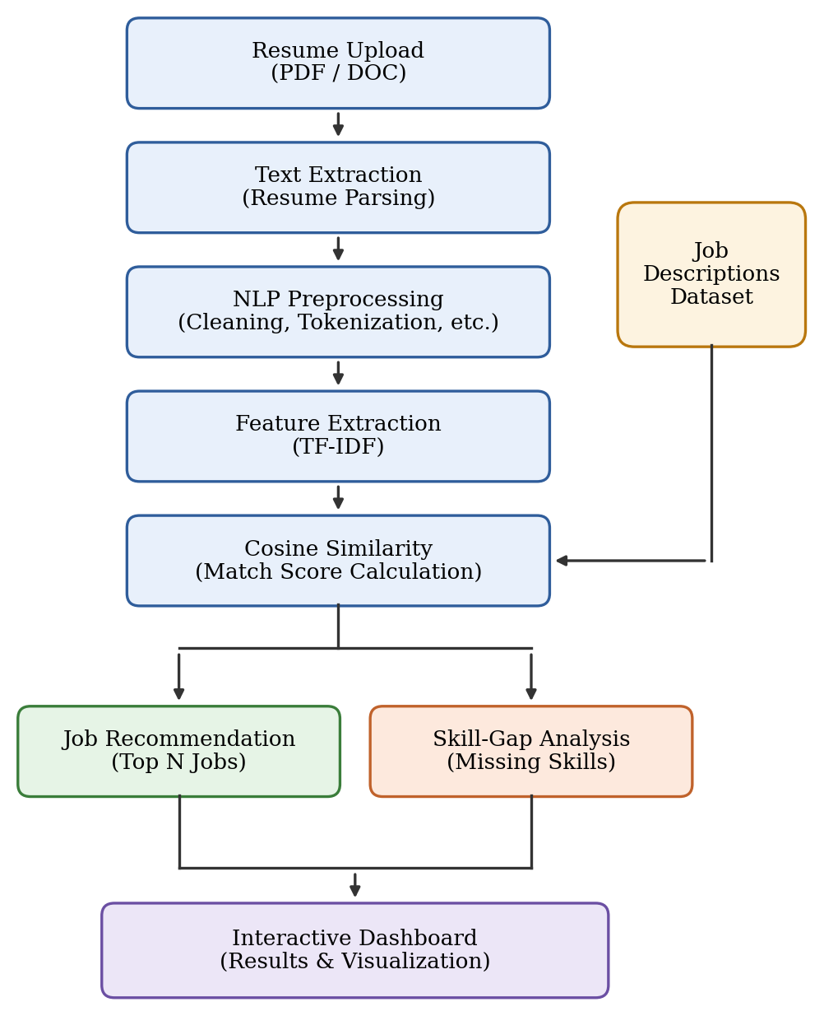
Fig. 1. Proposed system design
V. RESULT AND DISCUSSION
For each uploaded resume, the system produces a ranked list of jobs from the job descriptions dataset. Every entry carries a match percentage derived from the cosine similarity between the resume and job-description vectors, so the job with the highest score is presented as the most relevant. Alongside each recommendation the system lists the matched skills and the missing skills, and all of these outputs are shown together on the interactive dashboard.
This output serves two groups. For a candidate, the ranked list shows which opportunities fit their profile and the missing-skills list shows what to learn to improve their match. For a recruiter, the scores provide a consistent, repeatable basis for screening, which reduces manual effort compared with reading each resume individually. Because matching rests on TF-IDF term weights, the scores are easy to explain: they follow directly from the skills and keywords shared by the resume and the job description.
The quality of matching depends on consistent terminology. As noted under challenges, synonyms and abbreviations for the same skill can lower the score for a well-suited candidate, so handling skill variants is an important direction for improving relevance.
[Add measured results here: accuracy and relevance on sample resumes, dataset size, and dashboard screenshots.]
VI. CONCLUSION AND FUTURE SCOPE
This paper presented a Smart Resume Screening and Job Recommendation System that combines NLP preprocessing, TF-IDF vectorization and cosine similarity to automate resume evaluation. The system ranks available jobs by relevance to a candidate’s profile, identifies the skills a candidate is missing for each job, and presents matched skills, missing skills, match percentages and rankings on an interactive dashboard. By integrating screening, matching, recommendation and skill-gap analysis in one system, it reduces manual screening effort, improves the efficiency of candidate–job matching and supports personalized, data-driven career guidance.
Future work should extend the system to handle scanned and varied resume formats and to treat skill synonyms and abbreviations more robustly. Fairness checks are needed to limit bias related to gender, institution or location, together with stronger privacy and security protection for personal data. The job-description database and required-skill sets should be kept up to date as market demand evolves, and the system should be scaled to process large volumes of resumes and job descriptions in real time.
REFERENCES
[1] K. Tejaswini et al., “Design and Development of Machine Learning Based Resume Ranking System,” 2022.
[2] Mohanty et al., “Resume–Job Match Scorer Using Cosine Similarity and Natural Language Processing,” 2025.
[3] Jadhav et al., “AI-Enabled Employment Matching Platform,” 2026.

